Hands On: AWS VPC Essentials
(Part – 2.1)
AWS VPC Private Link, Gateway Endpoint and Interface Endpoint

In this second part of VPC Essentials I am focused in AWS VPC Private link concept of VPC Endpoint and Endpoint Services.
AWS VPC Private link
AWS PrivateLink is a highly available, scalable technology that you can use to privately connect your VPC to services as if they were in your VPC. You do not need to use an internet gateway, NAT device, public IP address, AWS Direct Connect connection, or AWS Site-to-Site VPN connection to allow communication with the service from your private subnets.
AWS VPC Endpoint
- AWS VPC Endpoint are the implementation of PrivateLink within a VPC, enabling private connections to AWS services and custom endpoint services.
- VPC endpoint lets you privately connect your VPC to AWS services without requiring an Internet gateway. Instances in your VPC do not require public IP addresses to communicate with resources in the service.
- There are two types of VPC endpoints: interface endpoints and gateway endpoints;
    - Gateway endpoints: A gateway endpoint targets specific IP routes in an Amazon VPC route table, in the form of a prefix-list, used for traffic destined to Amazon DynamoDB and S3.

Gateway endpoints do not enable AWS PrivateLink.

There is no additional charge for using gateway endpoints.
    - Interface endpoints: Instances in your AMS (AWS Managed Services) environment can talk to supported services without leaving the Amazon network.

These services include some AWS managed services, services hosted by other AWS customers and partners in their own Amazon VPCs (referred to as endpoint services), and supported AWS Marketplace partner services

List of few interface endpoints supported by AMS are;
AWS CloudFormation, CloudWatch, SNS, SQS and Cloud trail etc.

Reference architectural diagram
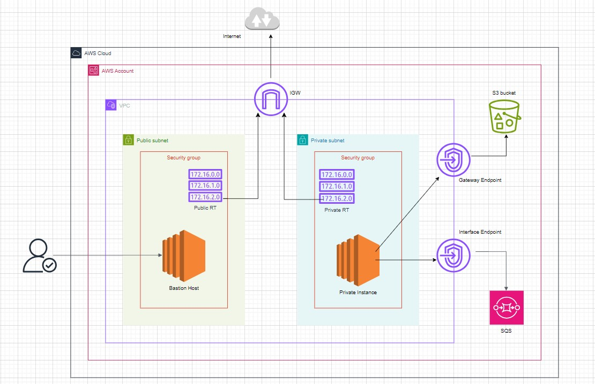

Gateway Endpoint – Hands on
Here I am doing a Hands-on for Accessing S3 from a VPC using a Gateway endpoint.
      - You can use two types of VPC endpoints to access Amazon S3: gateway endpoints and interface endpoints (by using AWS PrivateLink).

      - A gateway endpoint is a gateway that you specify in your route table to access Amazon S3 from your VPC over the AWS network.

      - Interface endpoints extend the functionality of gateway endpoints by using private IP addresses to route requests to Amazon S3 from within your VPC, on premises, or from a VPC in another AWS Region by using VPC peering or AWS Transit Gateway.
Considerations for S3 Gateway Endpoint:
- A gateway endpoint is available only in the Region where you created it. Be sure to create your gateway endpoint in the same Region as your S3 buckets.
- The rules for the security groups for your instances that access Amazon S3 through a gateway endpoint must allow traffic to and from Amazon S3. You can reference the ID of the Prefix List for Amazon S3 in security group rules.
- The network ACL for the subnet for your instances that access Amazon S3 through a gateway endpoint must allow traffic to and from Amazon S3.
- Gateway endpoints support only IPv4 traffic.

Steps:
For this Hands-on, I am skipped the steps for VPC creation and focused in Gateway endpoint and Interface Endpoint configurations.
- Create demo S3 bucket:
- Open the Amazon S3 console
- Choose "Create bucket."
- Enter a bucket name- “mycloud-demo-gateway-endpoint”
- Select the AWS Region where you are created the VPC and Gateway endpoint.
- Choose "Create bucket."

- Create Gateway Endpoint
- Open the Amazon VPC console
- In the navigation pane, choose Endpoints.
- Choose Create endpoint.
- For Service category, choose AWS services.
- For Services, add the filter Type = Gateway and select com.amazonaws.region. s3.
- For Route tables, select the route tables to be used by the endpoint-“mycloud-private-rt”. We automatically add a route that points traffic destined for the service to the endpoint network interface.
- For Policy, select Full access to allow all operations by all principals on all resources over the VPC endpoint.
- Choose Create endpoint.

- Edit the Security group for private subnet.

- We need to edit the security group of private subnets for allow in-bound and Out-bound access to S3 through Gateway-endpoint.

- Add http and https custom TCP protocol for Amazon managed Prefix-list ID for S3. (E.g.: pl-c3aa4faa - com.amazonaws.eu-north-1.s3).

(It will auto-generate when we create Gateway-endpoint for S3 route table association)

AWS-managed prefix lists are sets of IP address ranges for AWS services. These prefix lists are maintained by Amazon Web Services and provide a way to reference the IP addresses used by various AWS offerings. This can be particularly useful when configuring security groups, network ACLs, or other network-level controls within a VPC.
- Provide the permission for Private EC2 instance to communicate with S3

- Update IAM role for EC2 instance with S3 full access role.
- aws config: with root account or (IAM user with S3 full access) access key and secret access key

- List the S3 buckets from Private EC2.

Run the below command to list S3 buckets;

aws s3 ls

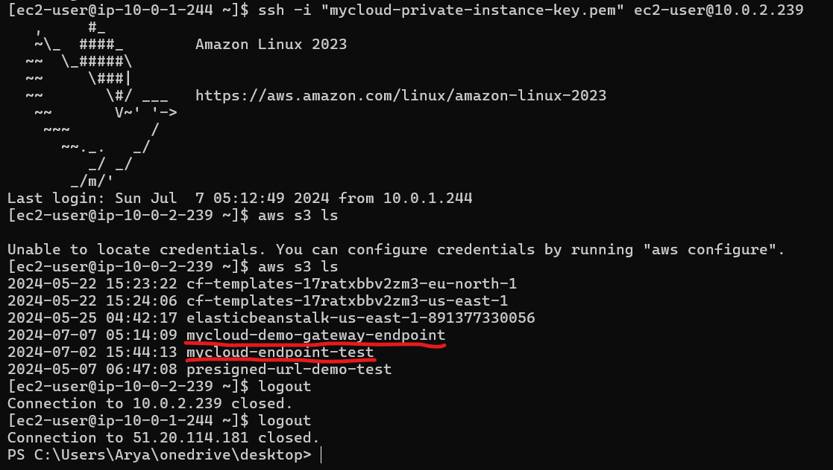

Here we can see the listed S3 buckets from Private Instance through Gateway-endpoint access without traffic to traverse the internet.

Interface Endpoint – Hands on
In second part of this hands-on, I am configuring an Interface endpoint for send a message to SQS (Simple queue service) privately from VPC powered by AWS PrivateLink.
- For each subnet that you specify from your VPC, we create an endpoint network interface in the subnet and assign it a private IP address from the subnet address range.

- To use private DNS, you must enable DNS hostnames and DNS resolution for your VPC.
- Create a security group for the endpoint network interface that allows the expected traffic from the resources in your VPC.
Here, the security group must allow inbound HTTPS traffic.

Steps:
- Create a SQS Queue
- Sign in to the AWS Console
- Open the SQS console
- Click on the "Create queue" button.
- Queue Name: Enter a name for your queue. The name must be unique within your AWS account and region. – “mycloud-sqs-queue”
- Queue Type: Choose "Standard"
- Set the Message Retention Period: for 15 min.
- After configuring the settings, click the "Create Queue" button.

- Create Security group for Interface endpoint
- Create a Security group – with name: “mycloud-interface-endpoint-sg”
- Allow inbound rule for https from private subnet CIDR Range.

- Enable DNS settings for VPC

- Enabling DNS settings in your AWS VPC is essential for resolving DNS names within your VPC. Specifically, you need to ensure that both DNS resolution and DNS hostnames are enabled.
- Select Your VPC
- Click on "Actions" at the top right, then select "Edit VPC Settings."
- Check the box that says "Enable DNS resolution” and "Enable DNS hostnames."
- Click "Save changes."

- Create VPC Interface Endpoint
- In the navigation pane, choose Endpoints.
- Choose Create endpoint.
- For Service category, choose AWS services.
- For Service name, select the service. – choose SQS with region same as our VPC.
- For VPC, select the VPC – “mycloud”

- Select Additional settings, Enable the "Enable DNS name" option is checked.
- In the "Modify Private DNS Names" dialog box, check the box for "Enable DNS name."

In this Hands-on: interface endpoint for Amazon SQS, enabling the DNS name ensures that the standard SQS endpoint URL will resolve to the VPC endpoint within your VPC, allowing secure and private communication.

Enabling the DNS name for an interface endpoint in your VPC allows you to use standard AWS service URLs that resolve to the private IP addresses of the endpoint within your VPC. This configuration is essential for secure, private access to AWS services from within your VPC.

- For Subnets, select private subnet – “mycloud-private-subnet”
- To choose the IP addresses for an endpoint network interface, select Designate IP addresses and enter an IPv4 address from the subnet address range.
- For IP address type, choose IPV4
- For Security groups, select the security groups to associate with the endpoint network interfaces for the VPC endpoint – “mycloud-sqs-interface-endpoint-sg”
- Choose Create endpoint.

- Send message to SQS Queue from Private EC2 Instance.
- Login to Private EC2 Instance from Bastion host.
- Run the below command;

aws sqs send-message --queue-url https://sqs.eu-north-1.amazonaws.com/891377330056/mycloud-queue --message-body "Hello, SQS!"

Components of this command:
- aws sqs send-message:
This is the AWS CLI command to send a message to an SQS queue.

- --queue-url https://sqs.eu-north-1.amazonaws.com/891377330056/mycloud-queue --message-body "Hello, SQS!"
: This specifies the URL of the SQS queue to which the message is being sent. The URL includes the region (eu-north-1), the AWS account ID (891377330056), and the queue name (mycloud-queue).

- message-body "Hello, SQS!"
: This is the content of the message you are sending to the queue. In this case, the message body is the string "Hello, SQS!".

- This will send a message “Hello, SQS!” to our SQS Queue.
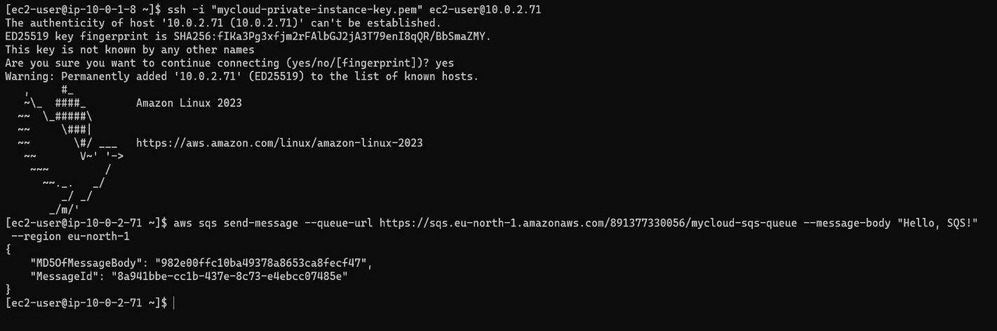

- We can check the message was received at mycloud-sqs-queue

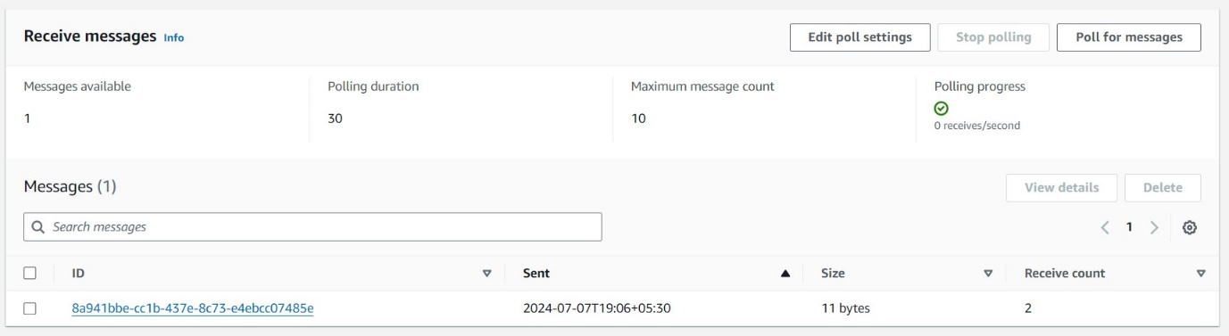

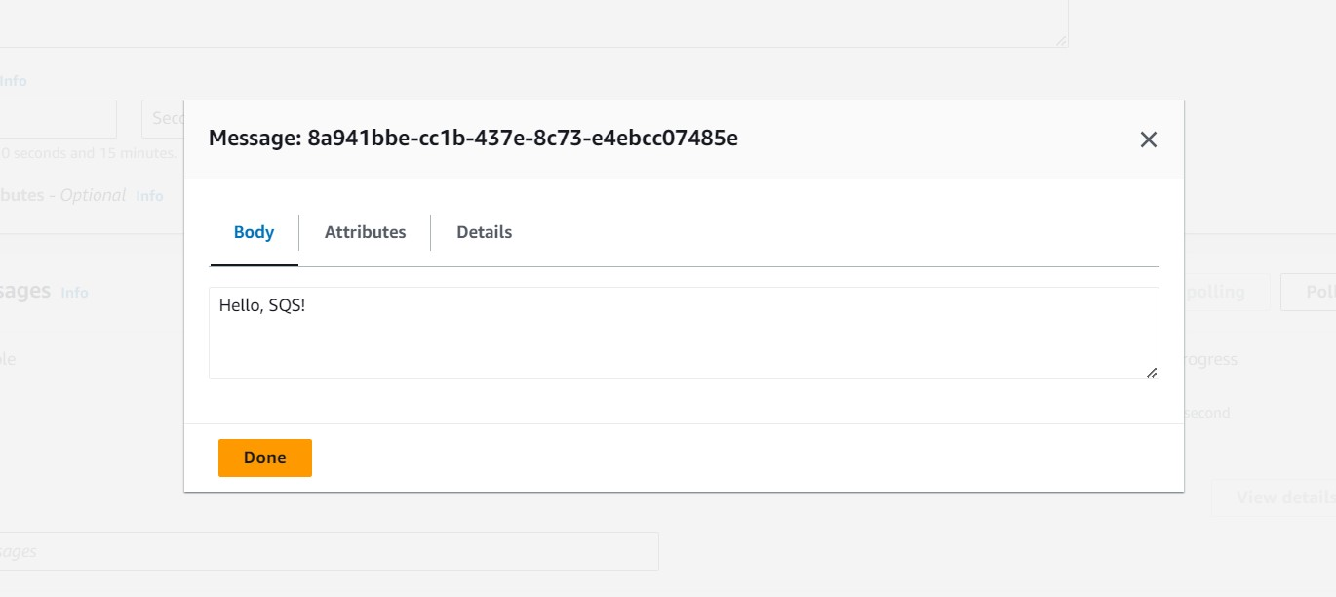
Note: if private DNS is enabled for your VPC endpoint (which is the default), you can continue using the standard SQS endpoint URL in your AWS CLI commands. If private DNS is disabled, you must use the VPC endpoint-specific DNS name.

--End--

